主题一、Why we choose to use Django?

1. What we are learning is Python and its IDE PyCharm.

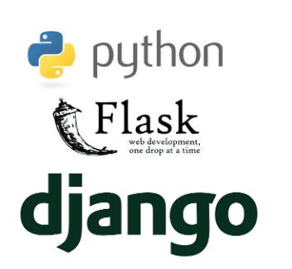

2. Why Django, not Flask or others?

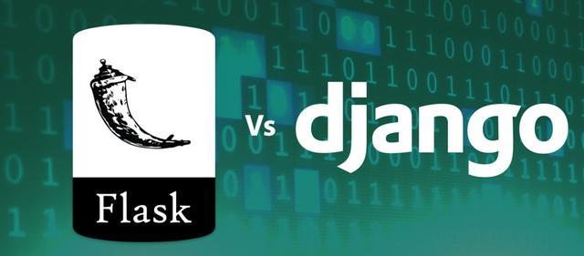

3. Where we applied?

主题二、About Bootstrap

1. What is Bootstrap?

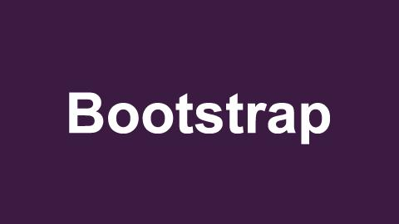

2. What benefits it brings?

3. Where we applied?



